**SQL major Assignment-Solutions**

**Q.1) Create a table “Station” to store information about weather**

**observation stations:**

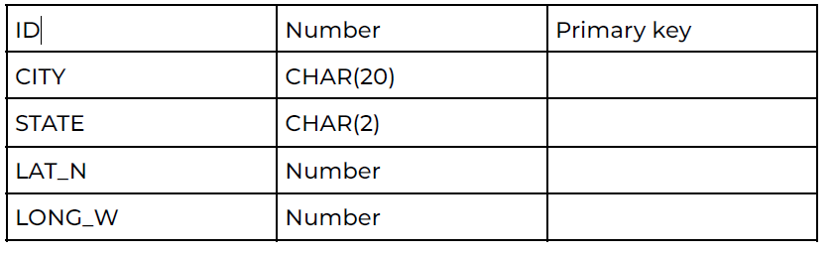

**Ans.1)**

**CODE:** **CREATE TABLE station**

**(**

**id number,**

**city char(20),**

**state char(2),**

**lat_n number,**

**long_w number,**

**primary key(id)**

**)**

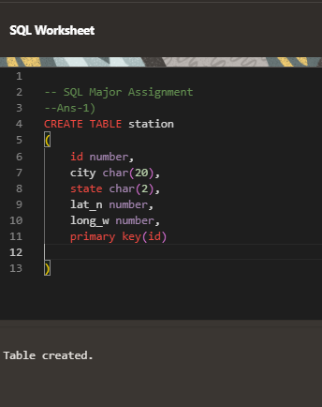

**Q.2) Insert the following records into the table:**

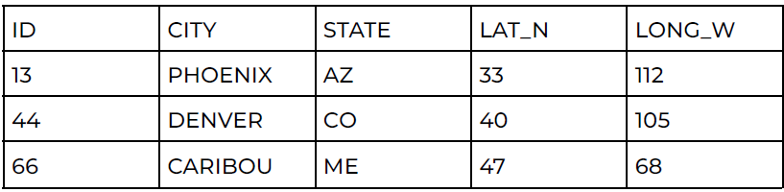

**Ans.2)**

**CODE:**  **insert into station VALUES ('13', 'PHOENIX', 'AZ', '33', '112');**

**insert into station VALUES ('44', 'DENVER', 'CO', '40', '105');**

**insert into station VALUES ('66', 'CARIBOU', 'ME', '47', '68');**

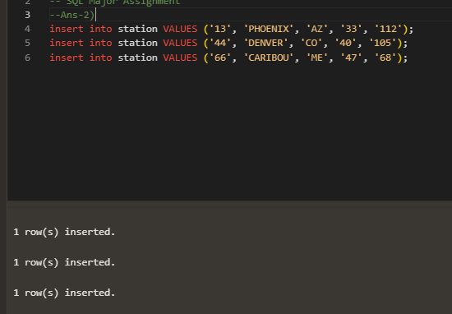

**Q.3) Execute a query to look at table STATION in undefined order.**

**Ans.3)**

**CODE:**  **SELECT * FROM Station**

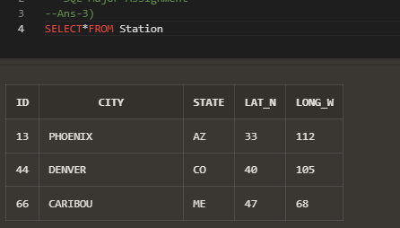

**Q.4) Execute a query to select Northern stations (Northern latitude >**

**39.7).**

**Ans.4)**

**CODE:**

**SELECT \***

**FROM Station**

**WHERE lat_n >39.7;**

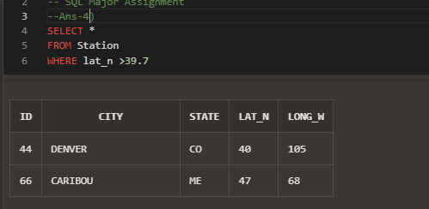

**Q.5) Create another table, ‘STATS’, to store normalized temperature and**

**precipitation data: (There will be no Duplicate ID and MONTH combination.)**

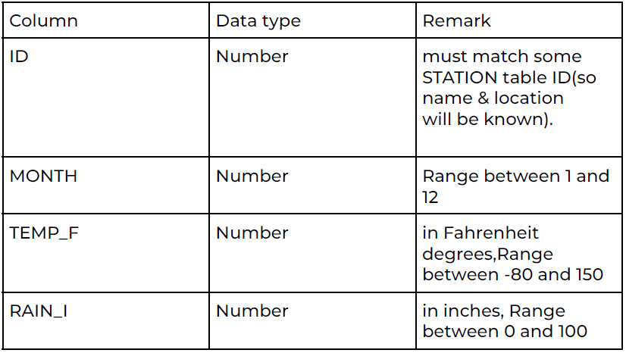

**Ans.5)**

**CODE:**

**CREATE TABLE STATS**

**(**

**id integer,**

**month integer CHECK (MONTH between 1 AND 12),**

**TEMP_F float(5,2) CHECK (TEMP_F between -80 AND 150),**

**RAIN_I float(5,2) CHECK (RAIN_I between 0 AND 100),**

**Constraint STA primary key (ID,MONTH),**

**CONSTRAINT STAA foreign key (ID) references STATION (ID)**

**)**

**IN MySQL**



**Q.6) Populate the table STATS with some statistics for January and July:**

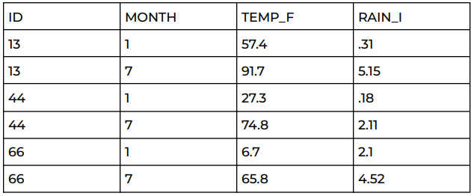

**Ans.6)**

**CODE:**

**insert into STATS VALUES ('13', '1', '57.4', '.31');**

**insert into STATS VALUES ('13', '7', '91.7', '5.15');**

**insert into STATS VALUES ('44', '1', '27.3', '.18');**

**insert into STATS VALUES ('44', '7', '74.8', '2.11');**

**insert into STATS VALUES ('66', '1', '6.7', '2.1');**

**insert into STATS VALUES ('66', '7', '65.8', '4.52');**

**IN MySQL**

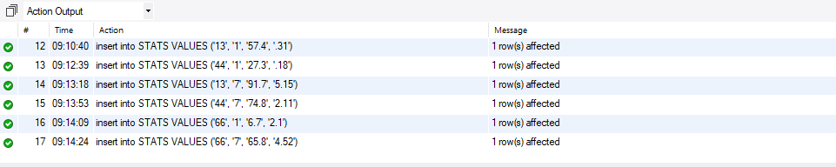

**Q.7) Execute a query to display temperature stats (from STATS table) for each city (from Station table):**

**Ans.7)**

**CODE:**

**Select city, month, temp_f from station**

**right join stats on station.id = stats.id ;**

**IN MySQL**

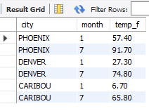

**Q.8) Execute a query to look at the table STATS, ordered by month and greatest rainfall, with columns rearranged. It should also show the corresponding cities.**

**Ans.8)**

**CODE:**

**select month, RAIN_I, city from stats**

**right join station on stats.id = station.id**

**order by month, RAIN_I desc;**

**IN MySQL**

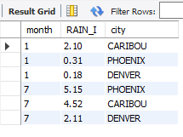

**Q.9) Execute a query to look at temperatures for July from table STATS, lowest temperatures first, picking up city name and latitude.**

**Ans.9)**

**CODE:**

**select city , month, TEMP_F, LAT_N from stats**

**right join station on stats.id = station.id**

**where month = '7'**

**order by TEMP_F;**

**IN MySQL**

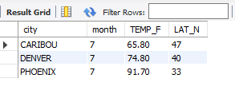

**Q.10) Execute a query to show MAX and MIN temperatures as well as average rainfall for each city.**

**Ans.10)**

**CODE:**

**select city, MAX(TEMP_F), MIN(TEMP_F), AVG(RAIN_I) from stats**

**right join station on stats.id = station.id**

**GROUP BY city;**

**IN MySQL**

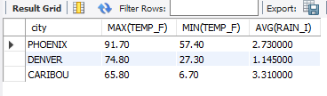

**Q.11) Execute a query to display each city’s monthly temperature in Celcius and rainfall in Centimeter.**

**Ans.11)**

**CODE:**

**select city, month,TEMP_F, ((TEMP_F-32)*5/9) AS TEMP_Celcius , RAIN_I, (RAIN_I*2.54) as RAIN_CM from stats**

**right join station on stats.id = station.id;**

**IN MySQL**

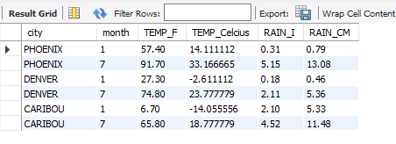

**Q.12) Update all rows of table STATS to compensate for faulty rain gauges known to read 0.01 inches low.**

**Ans.12)**

**CODE:**

**update stats set rain_i= rain_i+0.01 where id =13;**

**update stats set rain_i= rain_i+0.01 where id =44;**

**update stats set rain_i= rain_i+0.01 where id =66;\**

**select * from stats**

**IN MySQL**



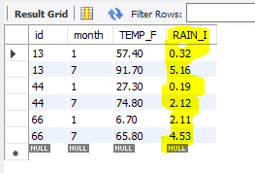

**Q.13) Update Denver's July temperature reading as 74.9**

**Ans.13)**

**CODE:**

**Update stats set temp_f = '74.9' where (id = 44) and (month = 7);**

**select city, month, temp_f from stats**

**right join station on stats.id = station.id**

**where (month=7) and (city = 'denver');**

**IN MySQL**



